Project Final Report
Professor Jefferson Bien-Aime
Wendy Fung-Wu, Daniel Ohebshalom, Shafayet Hasan
12/21/2025

Property Management

1. Introduction
Our goal for developing the Property Management System (PMS) project is to fulfill the necessity of a centralized, reliable, and scalable database solution for handling both residential and commercial properties for our client. Real estate companies dealing with property management face a large amount of data related to properties, owners, tenants, leases, vendors, inspections, financial transactions, and more. Handling such a massive amount of information using traditional methods or fragmented systems would prove to be inefficient. This project aims at designing and developing a normalized relational database with the intent to support operations on properties, promoting transparency and accessibility among all users of the database (i.e., the company staff). By implementing structured data storage and role-specific access points, the project will improve operational efficiency, data integrity, and decision-making capabilities for the staff present.

2. Business Overview and System Requirements

2.1 Business Description
The business entity portrayed in this case is a property management company mandated with managing different properties on behalf of their owners. With the management of multiple different properties comes a mass of data, which can be fragmented, resulting in redundancies, inconsistencies, and limited reporting abilities for all the data currently present for the company to use. The company manages tenant agreements,
is responsible for rent payments, supervises repair requests, oversees different vendors, conducts inspection services, provides financial statements, and more. To operate effectively, this company requires a system where all the information concerning operations and financial matters is handled in a synchronized and secure way. In turn, this will improve data integrity and support daily operations whilst reducing errors. We seek to
-Maintain records for properties, owners, tenants, leases, vendors, inspections, and costs
-Track rent payments, maintenance expenses, and vendor invoices
-Support lease lifecycle management (creation, updates, renewals, terminations)
-Provide portals for owners, tenants, vendors, and management staff
-Generate financial and operational reports
-Non-Functional Requirements
-Data accuracy and integrity
-Role-based access control and security
-System scalability
-Reliable backups and audit trails

2.2 System Requirements
The system is designed to support storage, recall, and handling of data in a business context in a reliable and safe manner. Certain functional requirement specifications include creating, updating, and removing entries, generating reports, and handling complicated queries for making decisions. As an added requirement, it must be able to maintain data integrity using primary and foreign keys. Non-functional requirements include system reliability, usability, scalability, and ensuring safety of business data. The database system must support scaling up with increasing amounts of business data without diminishing performance.

3. Cost–Benefit Analysis

3.1 Project Costs
The primary costs associated with the proposed system would include development time, software tools, and potential training requirements. Development costs consist of analysis, database design, implementation, testing, etc. Additional costs may include database management software licenses, ongoing or required updates, and maintenance. Of course, this is all based on what is currently in place across the company and is subject to change in that regard. Prices also vary on a location-by-location basis, with some offices having easier availability and therefore lower prices for some costs, namely licenses and server costs.

3.2 Project Benefits
The primary advantages of the proposed system would include improved operational efficiency, reduced data redundancy, and enhanced reporting capabilities, not to mention the security of the company’s assets. By centralizing data and implementing data integrity rules, the system minimizes errors that a human would otherwise perform in document analysis, which in turn ensures consistent and accurate information across all business functions, ultimately leading to better decision-making and long-term cost savings.

3.3 Cost–Benefit Summary
The benefits of the proposed system outweigh the associated costs, as we gain the following: improved data accuracy, reduced manual input/workload, and enhanced reporting capabilities, all justifying the initial investment in development and implementation, along with continued support for the system in the long term.
3.4 The Numbers
The total estimated development cost ranges between $115,000 and $185,000, split into the following:
- Planning & Analysis: $10k – $15k
- System Design & Development: $40k – $60k
- Database Infrastructure: $25k – $40k
- Testing & QA: $10k – $15k
- Implementation & Deployment: $10k – $20k
- Training & Change Management: $5k – $10k
- Project Management & Contingency: $15k – $25k

4. Conceptual Data Model

4.1 Entities (Business Objects)
Employee
Company staff who operate the property management business (administration, operations, accounting, etc.).
Office Staff (Employee Role/Subtype)
Employees who handle general office and administrative work.
Accountant (Employee Role/Subtype)
Employees who handle financial tasks for the company (e.g., tracking fees, payments, and financial compliance).
Property Owner
The customer (owner) who signs a management contract with the company and owns one or more properties managed by the business.
Property
A real estate unit managed by the company. Properties can be listed for rent and have business characteristics such as rent rate, availability, and supporting ownership documentation.
Renters (Tenants)
Individuals renting a property. Tenant records support rental operations such as tracking tenant identity, lease timing, and deposit status.
Contractor
External service providers who perform repairs/maintenance and can be used by the management company (and may be preferred by specific owners).
Property Inspection
An inspection event for a property. Used to document condition, compliance, and maintenance history.

4.2 Conceptual Relationships and Cardinalities
Property Owner → Property
- One Property Owner can own many Properties.
- Each Property belongs to one Property Owner.
Property → Renters
- One Property can have many Renters over time.
- Each Renter rents one Property (at a given time).
Property → Property Inspection
- One Property can have many Property Inspections.
- Each Inspection is for one Property.
Contractor ↔ Property Owner (Preference / Vendor Relationship)
- A Property Owner can have preferred Contractor(s).
- A Contractor may serve many Owners.
Employee → Office Staff / Accountant (Role Specialization)
- Employees may be categorized by role (Office Staff, Accountant).
- Each role record corresponds to a single Employee.
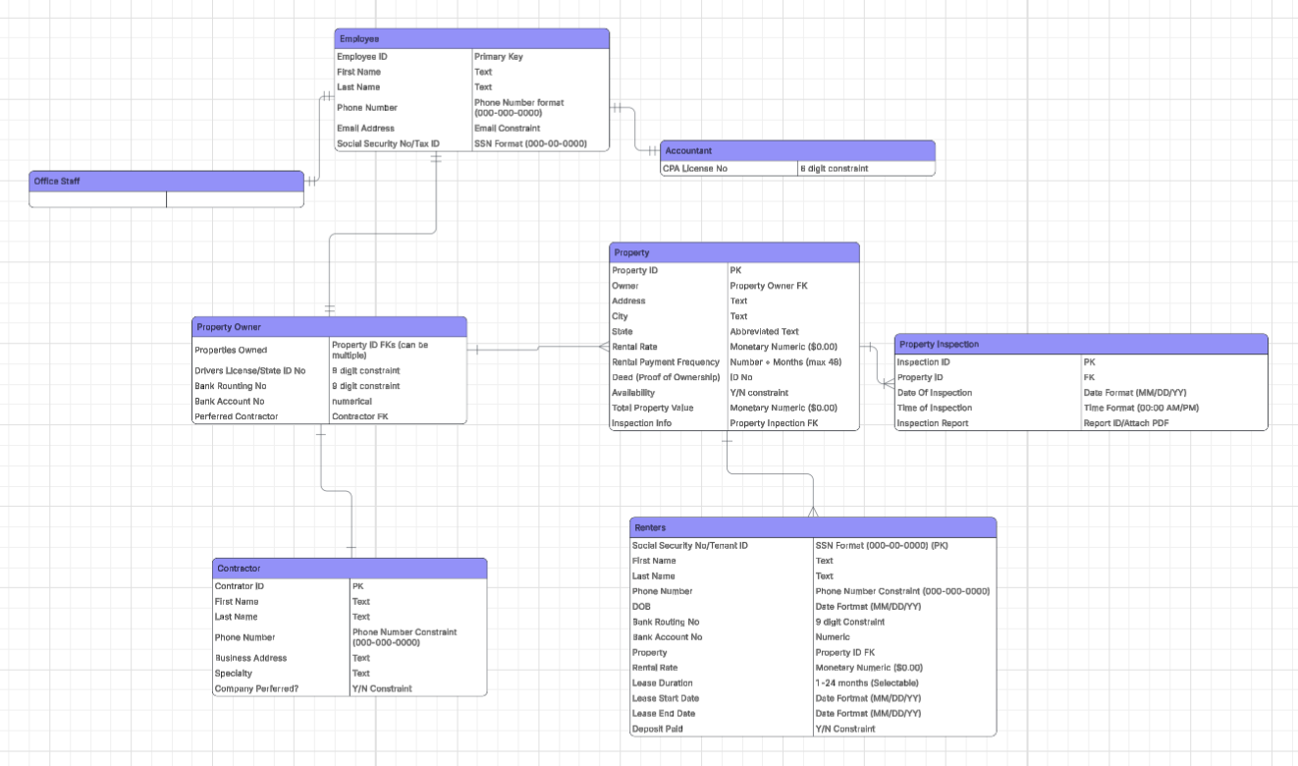

5. Logical Data Model

5.1 Relations (Tables), Primary Keys, Foreign Keys

EMPLOYEE
Stores employee identity and contact information.
- PK: Employee_ID
- Attributes: First_Name, Last_Name, Phone_Number, Email_Address, Social_Security_No/Tax_ID

OFFICE_STAFF
Represents the Office Staff role for an employee.
- PK/FK: Employee_ID → EMPLOYEE(Employee_ID)
- Logical meaning: this table exists to represent role membership without duplicating employee attributes.

1. ACCOUNTANT
Represents the Accountant role for an employee.
- PK/FK: Employee_ID → EMPLOYEE(Employee_ID)
- Attributes: CPA_License_No

2. PROPERTY_OWNER
Store owner/customer information needed for property management and payments.
- PK: Propertyowner_ID
- Attributes (examples): Driver_License/State_ID, Bank_Routing_No, Bank_Account_No
- Optional FK (if one preferred contractor): Preferred_Contractor_ID → CONTRACTOR(Contractor_ID)

3. CONTRACTOR
Stores third-party contractor/vendor information.
- PK: Contractor_ID
- Attributes: First_Name, Last_Name, Phone_Number, Business_Address, Specialty, Company_Preferred (Y/N)

4. PROPERTY
Stores managed property information and rental/listing details.
- PK: Property_ID
- FK: Owner_ID → PROPERTY_OWNER(Owner_ID)
- Attributes: Address, City, State, Rent_Rate, Rental_Payment_Frequency, Deed/Proof_of_Ownership, Availability, Total_Property_Value

5. RENTERS
Stores tenant information and basic lease/rental tracking fields.
- PK: Social_Security_No / Tenant_ID
- FK: Property_ID → PROPERTY(Property_ID)
- Attributes (examples): First_Name, Last_Name, Phone_Number, DOB, Bank_Routing_No, Bank_Account_No, Lease_Start_Date, Lease_End_Date, Lease_Duration, Deposit_Paid, Rental_Rate

6. PROPERTY_INSPECTION
Stores inspection events and inspection documentation.
- PK: Inspection_ID
- FK: Property_ID → PROPERTY(Property_ID)
- Attributes (examples): Date_of_Inspection, Time_of_Inspection, Inspection_Report

5.2 Logical Relationships (Implemented by Foreign Keys)
- PROPERTY_OWNER (1) → (N) PROPERTY via PROPERTY.Owner_ID
- PROPERTY (1) → (N) RENTERS via RENTERS.Property_ID
- PROPERTY (1) → (N) PROPERTY_INSPECTION via PROPERTY_INSPECTION.Property_ID
- EMPLOYEE (1) → (0/1) ACCOUNTANT via ACCOUNTANT.Employee_ID
- EMPLOYEE (1) → (0/1) OFFICE_STAFF via OFFICE_STAFF.Employee_ID
- CONTRACTOR can be referenced by PROPERTY_OWNER (Preferred_Contractor_ID)

5.3 Logical Integrity Rules (Business Logic Reflected in Design)
- A Property must reference an existing Property Owner (PROPERTY.Owner_ID is required).
- A Renter must reference an existing Property (RENTERS.Property_ID is required).
- An Inspection must reference an existing Property (PROPERTY_INSPECTION.Property_ID is required).
- Email and identification fields (SSN/Tax ID, CPA License) should be treated as unique where applicable to prevent duplicate identities.
- Lease rules supported at the logical level:
  - Lease_Start_Date and Lease_End_Date must be valid dates.
  - Deposit_Paid is stored as a Y/N status.
  - Enforce max 4 weeks and renewals through application rules or by moving lease fields into a separate LEASE table later.


6. Physical Data Model
The physical data model translates the logical design into a database-specific implementation in the MySQL server that implements the previously inserted data into the model for properly synced storage. The physical model includes table structures, data types, constraints, and indexes based on the DBMS that ensure data integrity and proper querying. Such constraints include limiting to just numbers (INT), a specific format of characters (VARCHAR), or a True/False (BOOLEAN). The creation of the physical model’s tables and attributes for record storage in MySQL is as follows:
CREATE TABLE Office (
- Office_ID INT PRIMARY KEY,
- Address VARCHAR(100),
- City VARCHAR(50),
- Country VARCHAR(50),
- Phone_Number VARCHAR(25),
- No_of_Properties INT
- ) ENGINE=InnoDB;

CREATE TABLE Employees (
- Employee_ID INT PRIMARY KEY,
- First_Name VARCHAR(45) NOT NULL,
- Last_Name VARCHAR(45) NOT NULL,
- Phone_Number VARCHAR(25),
- Social_Security_No CHAR(9) UNIQUE,
- Home_Address VARCHAR(100),
- Office_Company_Office_ID INT,
- Department VARCHAR(45),

- FOREIGN KEY (Office_Company_Office_ID)
- REFERENCES Office(Office_ID)
- ) ENGINE=InnoDB;
CREATE TABLE Office_Staff (
- Employee_Employee_ID INT PRIMARY KEY,

- FOREIGN KEY (Employee_Employee_ID)
- REFERENCES Employees(Employee_ID)
- ON DELETE CASCADE
- ) ENGINE=InnoDB;
CREATE TABLE Accountant (
- Employee_Employee_ID INT PRIMARY KEY,
- CPA_License INT,

- FOREIGN KEY (Employee_Employee_ID)
- REFERENCES Employees(Employee_ID)
- ON DELETE CASCADE
- ) ENGINE=InnoDB;
CREATE TABLE Property_Owner (
- Social_Security_No_TaxID CHAR(9) PRIMARY KEY,
- Drivers_License_State_ID INT,
- Bank_Routing_No INT,
- Bank_Account_No INT,
- Preferred_Contractor INT,
- Properties_Owned INT,
- Properties_Listed INT,
- Individual_Organization VARCHAR(45),
- Employee_Employee_ID INT,

- FOREIGN KEY (Employee_Employee_ID)
- REFERENCES Employees(Employee_ID),
- FOREIGN KEY (Preferred_Contractor)
- REFERENCES Contractor(Contractor_ID)
- ) ENGINE=InnoDB;
CREATE TABLE Contractor (
- Contractor_ID INT PRIMARY KEY,
- First_Name VARCHAR(45),
- Last_Name VARCHAR(45),
- Phone_Number VARCHAR(25),
- Business_Address VARCHAR(100),
- Specialty VARCHAR(45),
- Company_Preferred BOOLEAN
- ) ENGINE=InnoDB;
CREATE TABLE Property (
- Property_ID INT PRIMARY KEY,
- Address VARCHAR(100),
- City VARCHAR(50),
- Country VARCHAR(50),
- Deed_ID INT,
- Listed BOOLEAN,
- Total_Property_Value DECIMAL(12,2),
- Property_Owner_Owner_ID CHAR(9),

- FOREIGN KEY (Property_Owner_employee_ID)
- REFERENCES Property_Owner(Social_Security_No_TaxID)
- ) ENGINE=InnoDB;
CREATE TABLE Lease (
- Lease_ID INT PRIMARY KEY,
- Rental_Rate DECIMAL(8,2),
- Lease_Start_Date DATE,
- Lease_End_Date DATE,
- Deposit_Paid BOOLEAN,
- Property_Property_ID INT,

- FOREIGN KEY (Property_Property_ID)
- REFERENCES Property(Property_ID)
- ) ENGINE=InnoDB;
CREATE TABLE Renters (
- Social_Security_No CHAR(9) PRIMARY KEY,
- First_Name VARCHAR(45),
- Last_Name VARCHAR(45),
- Phone_Number VARCHAR(25),
- DOB DATE,
- Bank_Routing_No INT,
- Bank_Account_No INT,
- Lease_Lease_ID INT,

- FOREIGN KEY (Lease_Lease_ID)
- REFERENCES Lease(Lease_ID)
- ) ENGINE=InnoDB;
This model ensures optimal performance and enforces data integrity through primary key and foreign key constraints. The physical design is tailored to support the system’s functional and non-functional requirements and its security settings.
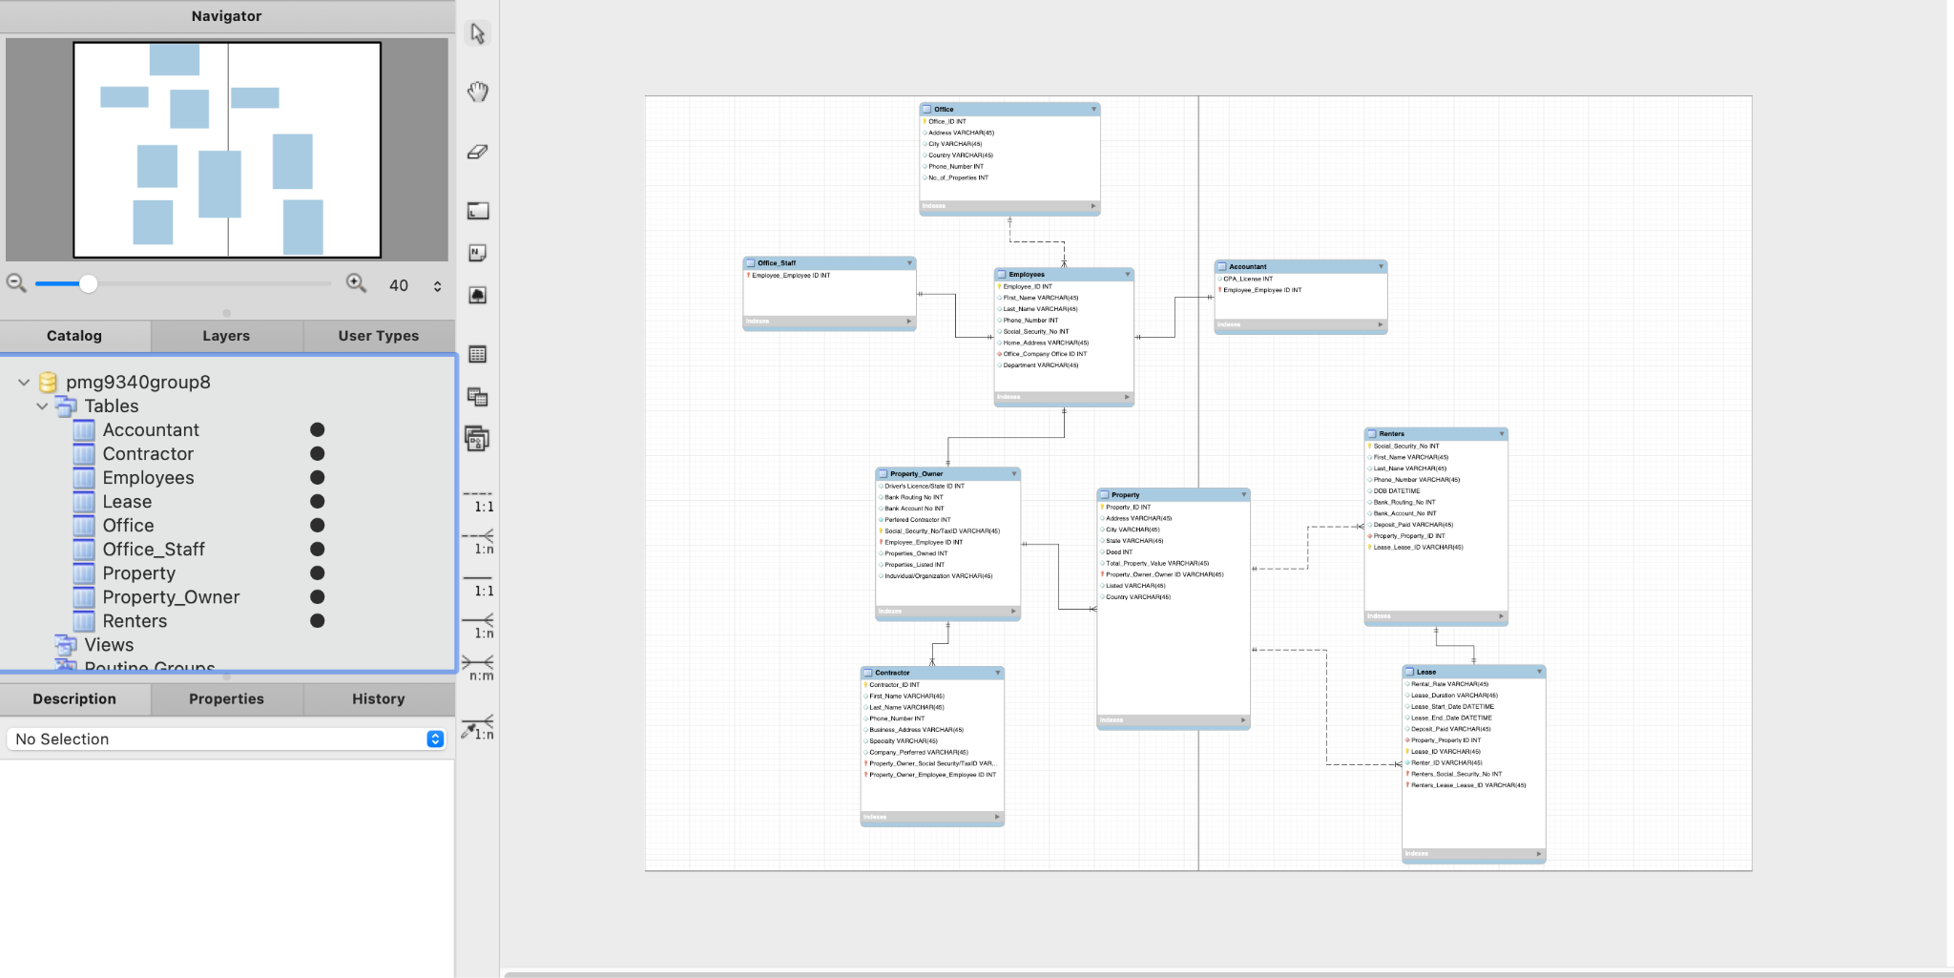

7. Normalization and Functional Dependencies

7.1 Normalized Relations
In this database, every table sticks to a single subject and only holds atomic values. We normalized each relation to cut out redundancy and dependence anomalies, keeping queries and outputs consistent.

7.2 Functional Dependencies
We map out and identify functional dependencies to ensure that non-key attributes depend only on the primary key. This process allowed us to avoid any partial and/or transitive dependencies.

7.3 Normal Forms Achieved
The database design achieves all three Normal Forms (1NF, 2NF, 3NF). The first was achieved and was dependent upon the atomicity of values and the removal of repeating groups. The second by removing partial dependencies, and the third had us remove transitive dependencies. The final result is displayed on our physical model.

7.4 Denormalization
To improve query performance in necessary situations, the use of limited denormalization was considered. A careful balance between performance improvements and data integrity guided how any denormalization decisions were made.

8. Database Implementation (SQL DDL)
The database was implemented using SQL Data Definition Language (DDL) statements to create tables, define primary keys, and establish foreign key relationships within our dataset. To create and later match tables in the ERD, the following query is run in MySQL for each table outlining their attributes, primary keys, foreign keys, and text convention types such a character only, integer only, or a specific format such as a phone number, which is then synchronized to the ERD using the synchronize model function in the MySQL server application.
CREATE TABLE Employees (
Employee_ID INT PRIMARY KEY,
First_Name VARCHAR(45) NOT NULL,
Last_Name VARCHAR(45) NOT NULL,
Phone_Number VARCHAR(25),
Social_Security_No CHAR(9) UNIQUE,
Home_Address VARCHAR(100),
Office_Company_Office_ID INT,
Department VARCHAR(45),

FOREIGN KEY (Office_Company_Office_ID)
REFERENCES Office(Office_ID)
) ENGINE=InnoDB;

8.1 Data Entry Methods
Data was entered into the database using SQL INSERT statements and user-friendly forms. This approach ensures accuracy and consistency while allowing efficient data input. For example, to add individual employees into the dataset and have it appropriately utilized by the ERD, you insert it with the following SQL query, which is then added, read, and can be interpreted through SQL queries with other data records. The data conventions established in the table must be followed so that the data can be read properly, as shown here for each individual record:
insert into Employees (employee_id, first_name, last_name, phone_number, social_security_no, home_address, department) values (257388, 'Lazar', 'Sackey', 'lsackey0@house.gov', '419-94-1724', '8 Vermont Point', 'Office Staff');

9. Forms, Reports, and Queries

9.1 Forms
Forms were designed to simplify data entry and ensure user input validation. Each form corresponds to a specific table or business function and includes validation rules to prevent incorrect data entry. Here is a form we created for this project that demonstrates how to add a new tenant to the system using the insert method in SQL.
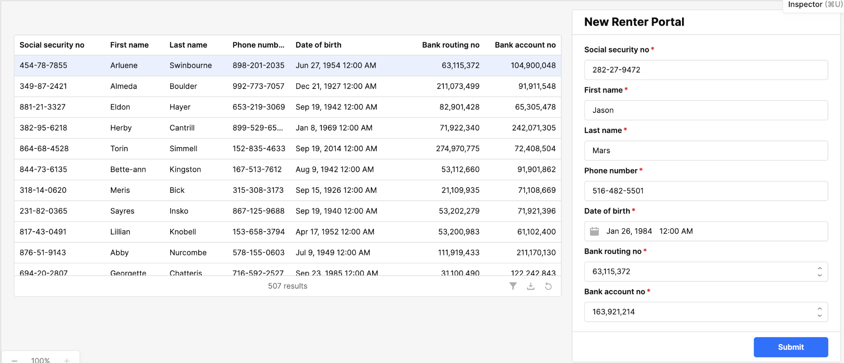

9.2 Reports
Reports provide summarized and formatted views of data to support management decisions. Each report was designed to present relevant information clearly and concisely. Based on SQL queries that can be used for this project, here are some of the reports that were populated in retool:
Filtering Properties by country:
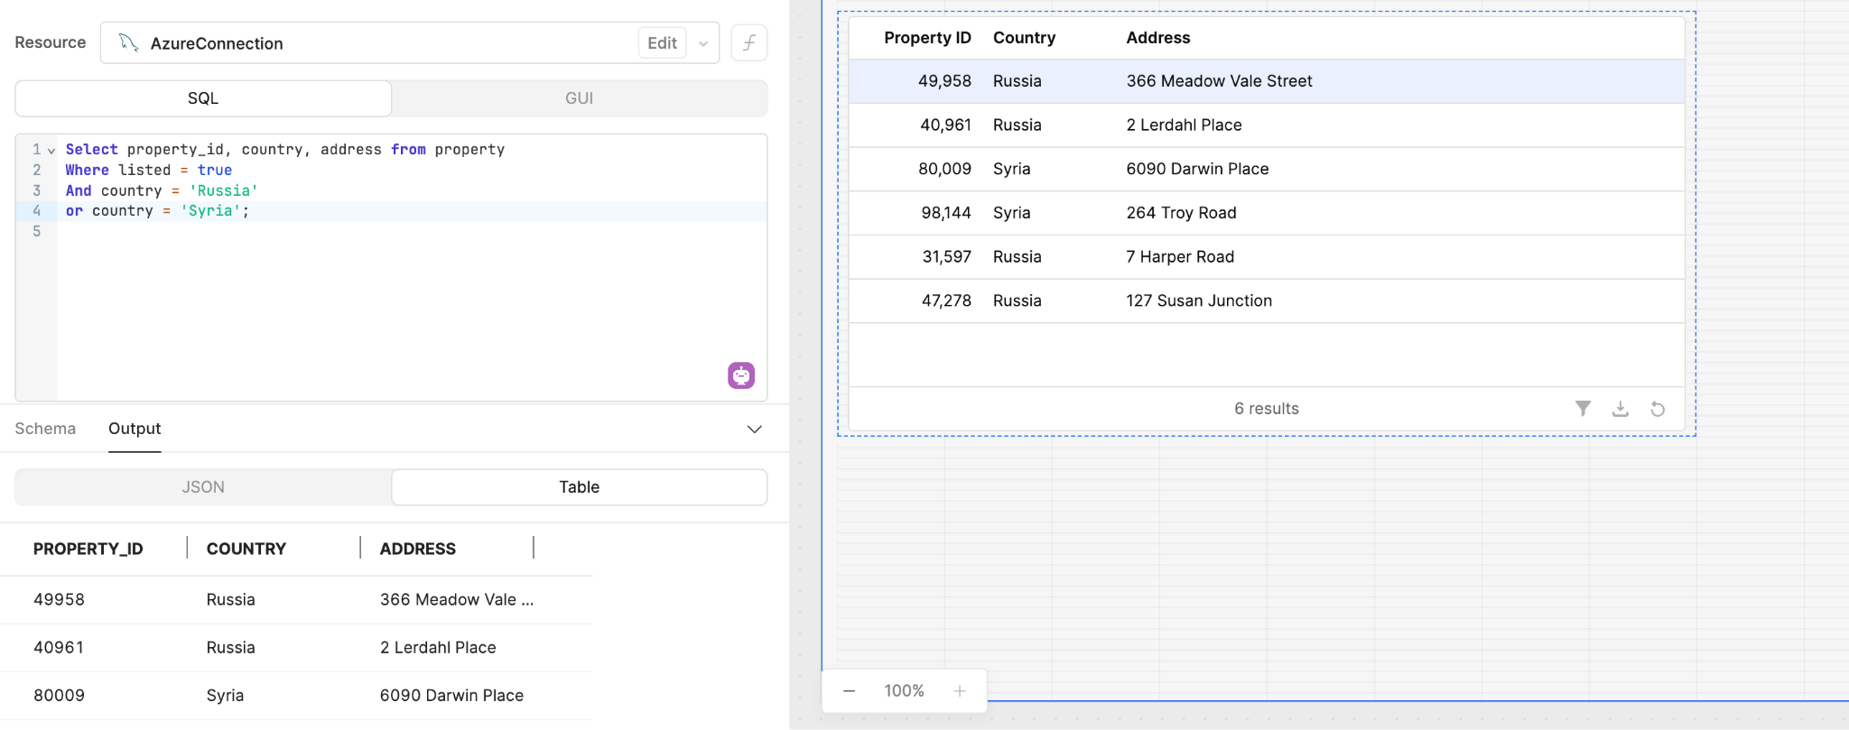
Checking to see if a lease had their deposit paid:
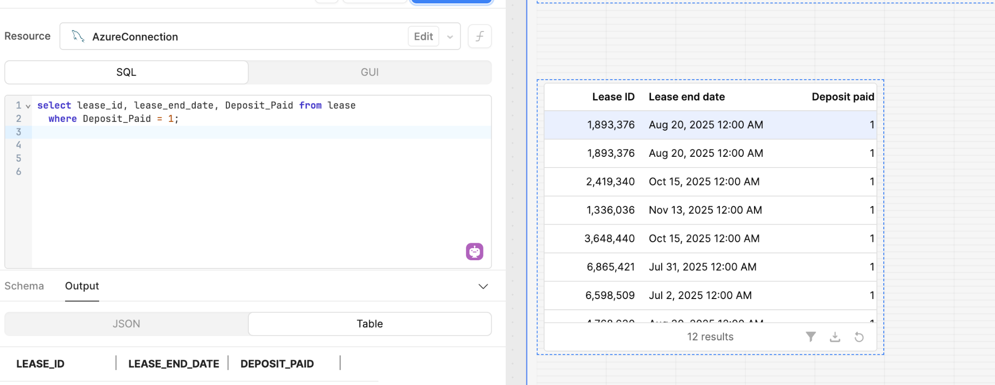

9.3 Queries
Queries were developed in SQLusing the newly implemented database management system to retrieve specific data based on business needs. These queries support reporting, analysis, and operational tasks and can be interpreted however the querier sees fit. Here are examples to show how queries best benefited this specific company in property management:
To select all current and past renters from the database:
Select * from Renters;
To check when the lease end data is for each renter who paid for their deposit:
select lease_id, lease_end_date, deposit_paid from lease
where Deposit_Paid = 1;
To analyze the properties in certain countries that are listed:
Select property_id, country, address from property
Where listed = true
And country = 'Russia'
or country = 'Syria';

10. Navigation Form
The Navigation Form serves as the main interface for the application and what is used by the employees, allowing users to easily access forms, reports, and queries without complex SQL. It organizes system components logically and improves overall usability. For this example, we created a retool interface that sheaths all of the internal makings of the database management system for the company’s employees. On Retool, this is present, so once a SQL query is ran it could be further interpreted through a menu system without editing the code in place. Here is the navigation form made in Retool that shows how to filter data records using forms and not SQL code:
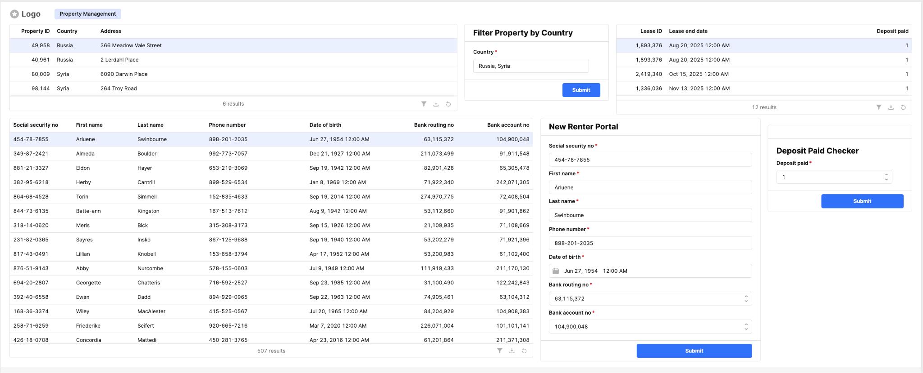

11. Conclusion

11.1 Group Experience
Throughout this project, the group gained valuable experience in database design and implementation. The most challenging aspects included normalization and designing recursive queries for the data, while creating basic tables and forms was more straightforward since it required our common sense into what went into each table and how it could be recorded in the final database. The project enhanced the group’s understanding of relational databases and SQL and how it can best be utilized to solve complex problems relating to data, while also designing a property management ERD that covered all of the firm’s needs to both modernize and optimize their operations.

11.2 System Effectiveness
For this company in particular, the proposed system very successfully meets the identified business requirements for the property management company. All of the previously paper-based data is now accessible and digitized into a secure system that can be recalled and interpreted by anyone in the company who sees fit. The database structure we created for the company supports accurate data storage of the business’ facets, an integrity system, and security that will protect the company’s data from even the toughest attacks or malpracitices, demonstrating that the proposed benefits can be realized and the flow of business has never been more efficient for this multinational company with the true potential yet to be realized.

11.3 Final Comments
In conclusion, this project provided practical insight into database system development and understanding how a property management team may store and structure their data. If the project were to be completed again, additional time would be allocated to performance testing and more research into real-world firms to see how they structure their data, thus gauging how we could improve future models across all industries and diversify our approaches. For example, we could look over the database of a private equity company and utilize similar approaches since PE and Real Estate have similar internal structures with asset ownership. Overall, the system effectively addresses the business problem and provides a solid foundation for future enhancements.

